DEPARTMENT OF COMPUTER SCIENCE
UNIVERSITY OF SIALKOT

Contact Book Management System
Object Oriented Programming - Semester Project Report

Submitted by:
Umme Habiba - Roll No. 040
Shifa Fatima - Roll No. 047
Zahra Dilawar - Roll No. 013

Course: Object Oriented Programming (BSSE - 2nd Semester)
Session: 2025-2029
Submission Date: July 2026

1. Introduction
Most people save their contacts in random places - some in phone memory, some in WhatsApp, some just written somewhere. Because of this it becomes hard to search for someone, and sometimes the same person ends up saved twice with different numbers. In this project we made a Contact Book Management System in C++ that saves contacts permanently in a file, separates them into Personal and Business type, finds duplicate entries so the same contact never gets saved twice, lets the user make groups, and also keeps track of what was searched and how many times. We tried to use as many OOP concepts as possible while designing this.

2. Requirement Elicitation
Before starting the coding part, we sat together as a group and went through the steps given in Section 3 of the manual - who will use the system, what are the main things (entities), what data they hold, what actions the user needs, and how the classes are related to each other. Our filled worksheet is given below.
Section | Our Answer
Entities identified | Contact, PersonalContact and BusinessContact (these are two types of Contact), Group, and SearchLog (for keeping track of searches).
Attributes per entity | Contact - id, name, email, phone, address  PersonalContact - relation (like cousin, friend)  BusinessContact - company name  Group - group id, group name, list of contact ids  SearchLog - keyword, how many times searched, last time searched
Functional requirements | - add a new contact  - view all contacts  - update a contact  - delete a contact  - search contact by typing part of name/email/phone  - if a duplicate contact is added (same email or phone), skip adding it and show a message  - make groups and add contacts in them  - see which keyword was searched most  - everything should save in file and load back automatically
Relationships and justification | PersonalContact/BusinessContact and Contact = inheritance, because both are just a "type" of Contact, so is-a relationship fits here.  Contact and Group = many to many, we only store contact id inside group instead of copying the whole contact, because one contact can be in many groups and one group can have many contacts.
OOP concepts required and where applied | Encapsulation - all variables are private/protected, we use get and set functions  Inheritance - PersonalContact and BusinessContact take from Contact  Polymorphism - show() and report() are virtual, so correct version runs automatically  Function overloading - Contact class has two constructors  Operator overloading - we made our own == for checking duplicate  Dynamic memory - contacts are made using new and removed using delete  File handling - one class (FileManager) does all the saving/loading
Menu structure (draft) | 1. Add Contact  2. View All Contacts  3. Update Contact  4. Delete Contact  5. Search Contact  6. Manage Groups  7. Exit  8. View Search Statistics
Open questions / assumptions | We assumed that if email or phone number is same, it means it's a duplicate contact. In that case we don't make a new entry, we just show a message and skip adding it so the same contact isn't saved twice. We also assumed only one person will use this app at a time so we didn't add login/user accounts.

3. Objectives
- To design the classes and their relationships (composition, inheritance) before starting to code, not after.
- To actually use the OOP concepts we studied in class - encapsulation, inheritance, polymorphism, overloading, dynamic memory, file handling - in one working project.
- To handle duplicate contacts properly, so the same contact never gets added twice.
- To make sure data is not lost when the program is closed, by saving everything to a file and loading it back next time.
- To make a menu that is simple enough for a normal user to use without confusion.

4. System Description
There are 6 classes in total. Contact is the main/base class - it has the common data like name, email, phone, and address. PersonalContact and BusinessContact both inherit from Contact and just add one extra field of their own (relation and company), and they override show() and report() so polymorphism can be seen when the program runs. Group is used to put contacts into groups, but instead of copying full contact data into the group, we just save the id numbers, this is our many-to-many part. SearchLog remembers what keyword was searched, how many times, and when it was last searched. FileManager is the only class that touches the .txt files, every other class asks FileManager to save/load instead of doing it themselves. main.cpp only has the menu and calls the functions of other classes, it does not have any class logic written directly inside it.

5. UML Class Diagram
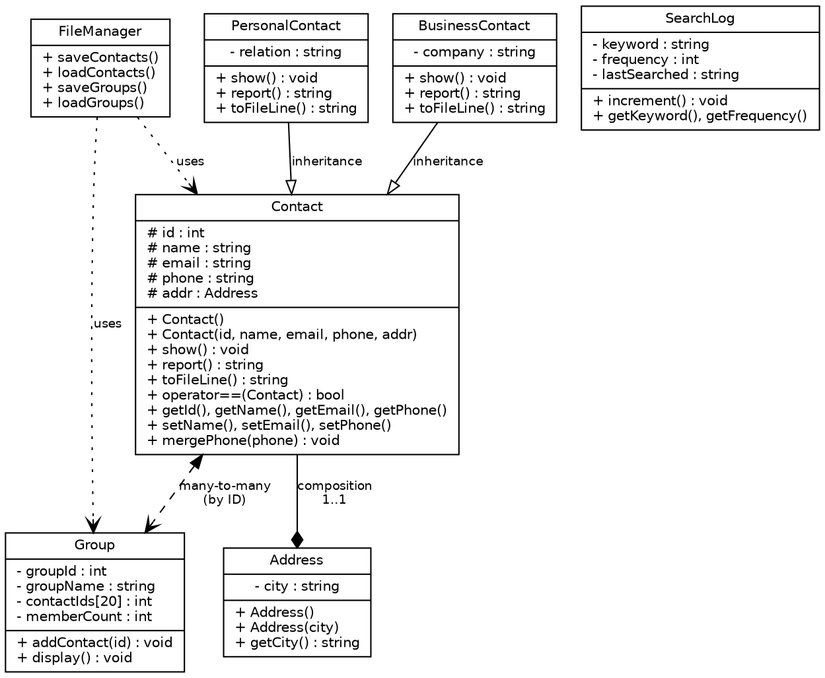

6. Class Descriptions
Class | Purpose | Key Attributes | Key Functions
Contact | Main class, has the data that every contact needs. | id, name, email, phone, address | show(), report(), operator==, getters/setters
PersonalContact | Child of Contact, for personal contacts like family/friends. | relation | show(), report() (overridden)
BusinessContact | Child of Contact, for business/work contacts. | company | show(), report() (overridden)
Group | Used to group contacts together (e.g. Family group). | groupId, groupName, contactIds[] | addContact(), display()
SearchLog | Keeps history of what was searched and when. | keyword, frequency, lastSearched | increment(), getFrequency()
FileManager | Handles all file saving and loading for the whole program in one place. | (static class, no objects needed) | saveContacts(), loadContacts(), saveGroups(), loadGroups()

7. OOP Concepts Implementation
Concept | Where and How
Classes and Objects | We made 6 classes - Contact, PersonalContact, BusinessContact, Group, SearchLog and FileManager.
Encapsulation | All variables are kept private or protected, they can only be accessed using get/set functions like getName() and setPhone().
Data Abstraction | When we call contact.show() we don't need to know how it works internally, we just get the result. Same for FileManager::saveContacts().
Inheritance | PersonalContact and BusinessContact both inherit from Contact using public inheritance, so they get id, name, email, phone automatically.
Polymorphism / Virtual Functions | show() and report() are written as virtual in Contact. So when we call them using a Contact pointer, the correct version (Personal or Business) runs automatically, this is runtime polymorphism.
Constructors and Destructors | Every class has a default and a parameterized constructor. Contact also has a virtual destructor so delete works properly even through a base class pointer.
Function Overloading | Contact class has two constructors with different parameters (one empty, one with all the values), this is overloading.
Operator Overloading | We overloaded == so we can directly compare two Contact objects to check if they are duplicate (same email or phone).
Dynamic Memory Allocation | Contacts are created using new (like new PersonalContact(...)) and deleted using delete when we remove a contact or close the program, so there is no memory leak.
File Handling | FileManager is the only class that reads/writes files. Contacts go into contacts.txt and groups go into groups.txt, both load back automatically when we run the program again.
Three-File Structure | We split our code into cb.h (declarations only), cb.cpp (definitions) and main.cpp (menu + calling functions, no class logic).

8. File Handling Description
We used two simple text files, contacts.txt and groups.txt. Both of these are only touched by the FileManager class, no other class opens a file directly. In contacts.txt, each line has one contact saved like this: type,id,name,email,phone,city,extra - here type is either P (Personal) or B (Business), and extra is either the relation or the company depending on which type it is. groups.txt saves each group as: groupId,groupName,memberId1,memberId2,... - so it only saves the id numbers of the members, not their full data again. Both files get updated every time something changes (add/update/delete), and they automatically load back when we start the program, so nothing is lost when we close it.

9. Sample Output
[Screenshots to be added here: main menu, adding a contact, duplicate contact being detected and skipped, update and delete working, making a group and viewing it, searching a keyword and checking the stats, and closing + reopening the program to show it loads old data back. Also add one screenshot of something that should fail, like searching a name that doesn't exist.]

10. Conclusion
While making this project we understood OOP concepts much better than just reading them from books. The most confusing part for us was deciding what to do with duplicate contacts - we decided that if the email or phone already matches an existing contact, we just skip adding it and show a message, so the same person never ends up saved twice. Keeping all the file saving/loading inside one FileManager class also made things a lot easier, because before that our contacts.txt and groups.txt were going out of sync with each other.

Complete Source Code

File 1: cb.h
#include <iostream>
#include <string>
#include <fstream>
#include <sstream>
#include <ctime>
using namespace std;

class Contact {
protected:
int id;
string name;
string email;
string phone;
string address;
public:
Contact();
Contact(int i, string n, string e, string ph, string a);
virtual void show();
virtual string report();
virtual string toFileLine();
bool operator==(Contact &c);
int getId();
string getName();
string getEmail();
string getPhone();
void setName(string n);
void setEmail(string e);
void setPhone(string ph);
virtual ~Contact();
};

class PersonalContact : public Contact {
private:
string relation;
public:
PersonalContact();
PersonalContact(int i, string n, string e, string ph, string a, string rel);
void show();
string report();
string toFileLine();
};

class BusinessContact : public Contact {
private:
string company;
public:
BusinessContact();
BusinessContact(int i, string n, string e, string ph, string a, string comp);
void show();
string report();
string toFileLine();
};

class Group {
private:
int groupId;
string groupName;
int contactIds[20];
int memberCount;
public:
Group();
Group(int gid, string gname);
void addContact(int cid);
void display();
int getGroupId();
string getGroupName();
int getMemberCount();
int getMemberAt(int index);
};

class SearchLog {
private:
string keyword;
int frequency;
string lastSearched;
public:
SearchLog();
SearchLog(string k);
void increment();
string getKeyword();
int getFrequency();
string getLastSearched();
};

class FileManager {
public:
static void saveContacts(Contact *arr[], int n);
static int loadContacts(Contact *arr[], int &nextId);
static void saveGroups(Group arr[], int n);
static int loadGroups(Group arr[]);
};

bool matchKeyword(string field, string key);
string currentTimestamp();

File 2: cb.cpp
#include "cb.h"

bool matchKeyword(string field, string key) {
return field.find(key) != string::npos;
}

string currentTimestamp() {
time_t now = time(0);
char buf[20];
strftime(buf, sizeof(buf), "%Y-%m-%d %H:%M", localtime(&now));
return string(buf);
}

Contact::Contact() {
id = 0; name = ""; email = ""; phone = "";
}

Contact::Contact(int i, string n, string e, string ph, string a) {
id = i; name = n; email = e; phone = ph; address = a;
}

void Contact::show() {
cout <<"ID: "<< id <<" | Name: "<< name <<" | Email: "<< email;
cout <<" | Phone: "<< phone <<" | City: "<< address << endl;
}

string Contact::report() {
return "Contact Report: " + name;
}

string Contact::toFileLine() {
return "C," + to_string(id) + "," + name + "," + email + "," + phone + "," + address + ",";
}

bool Contact::operator==(Contact &c) {
return email == c.email || phone == c.phone;
}

int Contact::getId() { return id; }
string Contact::getName() { return name; }
string Contact::getEmail() { return email; }
string Contact::getPhone() { return phone; }

void Contact::setName(string n) { name = n; }
void Contact::setEmail(string e) { email = e; }
void Contact::setPhone(string ph) { phone = ph; }

Contact::~Contact() {
}

PersonalContact::PersonalContact() : Contact() {
relation = "";
}

PersonalContact::PersonalContact(int i, string n, string e, string ph, string a, string rel) : Contact(i, n, e, ph, a) {
relation = rel;
}

void PersonalContact::show() {
cout <<"ID: "<< id <<" | Personal Contact -> Name: "<< name <<" | Relation: "<< relation;
cout <<" | Phone: "<< phone <<" | Email: "<< email <<" | City: "<< address << endl;
}

string PersonalContact::report() {
return "Personal Contact: " + name + " Relation: " + relation;
}

string PersonalContact::toFileLine() {
return "P," + to_string(id) + "," + name + "," + email + "," + phone + "," + address + "," + relation;
}

BusinessContact::BusinessContact() : Contact() {
company = "";
}

BusinessContact::BusinessContact(int i, string n, string e, string ph, string a, string comp) : Contact(i, n, e, ph, a) {
company = comp;
}

void BusinessContact::show() {
cout <<"ID: "<< id <<" | Business Contact -> Name: "<< name <<" | Company: "<< company;
cout <<" | Phone: "<< phone <<" | Email: "<< email <<" | City: "<< address << endl;
}

string BusinessContact::report() {
return "Business Contact: " + name + " Company: " + company;
}

string BusinessContact::toFileLine() {
return "B," + to_string(id) + "," + name + "," + email + "," + phone + "," + address + "," + company;
}

Group::Group() {
groupId = 0; groupName = ""; memberCount = 0;
}

Group::Group(int gid, string gname) {
groupId = gid; groupName = gname; memberCount = 0;
}

void Group::addContact(int cid) {
if (memberCount < 20) {
contactIds[memberCount] = cid;
memberCount++;
}
}

void Group::display() {
cout <<"Group -> ID: "<< groupId <<" Name: "<< groupName <<" Members: "<< memberCount <<" ->";
for (int i = 0; i < memberCount; i++) {
cout << contactIds[i] <<"";
}
cout << endl;
}

int Group::getGroupId() { return groupId; }
string Group::getGroupName() { return groupName; }
int Group::getMemberCount() { return memberCount; }
int Group::getMemberAt(int index) { return contactIds[index]; }

SearchLog::SearchLog() {
keyword = ""; frequency = 0; lastSearched = "";
}

SearchLog::SearchLog(string k) {
keyword = k; frequency = 1; lastSearched = currentTimestamp();
}

void SearchLog::increment() {
frequency++;
lastSearched = currentTimestamp();
}

string SearchLog::getKeyword() { return keyword; }
int SearchLog::getFrequency() { return frequency; }
string SearchLog::getLastSearched() { return lastSearched; }

void FileManager::saveContacts(Contact *arr[], int n) {
ofstream f("contacts.txt");
for (int i = 0; i < n; i++) {
f << arr[i]->toFileLine() << endl;
}
f.close();
}

int FileManager::loadContacts(Contact *arr[], int &nextId) {
ifstream f("contacts.txt");
int count = 0;
if (!f.is_open()) {
return 0;
}
string line;
while (getline(f, line)) {
if (line.empty()) continue;
stringstream ss(line);
string type, idStr, name, email, phone, city, extra;
getline(ss, type, ',');
getline(ss, idStr, ',');
getline(ss, name, ',');
getline(ss, email, ',');
getline(ss, phone, ',');
getline(ss, city, ',');
getline(ss, extra, ',');
int id = stoi(idStr);

if (type == "P") {
arr[count] = new PersonalContact(id, name, email, phone, city, extra);
} else if (type == "B") {
arr[count] = new BusinessContact(id, name, email, phone, city, extra);
} else {
arr[count] = new Contact(id, name, email, phone, city);
}
count++;
if (id >= nextId) {
nextId = id + 1;
}
}
f.close();
return count;
}

void FileManager::saveGroups(Group arr[], int n) {
ofstream f("groups.txt");
for (int i = 0; i < n; i++) {
f << arr[i].getGroupId() <<","<< arr[i].getGroupName();
for (int j = 0; j < arr[i].getMemberCount(); j++) {
f <<","<< arr[i].getMemberAt(j);
}
f << endl;
}
f.close();
}

int FileManager::loadGroups(Group arr[]) {
ifstream f("groups.txt");
int count = 0;
if (!f.is_open()) {
return 0;
}
string line;
while (getline(f, line)) {
if (line.empty()) continue;
stringstream ss(line);
string idStr, gname;
getline(ss, idStr, ',');
getline(ss, gname, ',');
arr[count] = Group(stoi(idStr), gname);

string memberStr;
while (getline(ss, memberStr, ',')) {
arr[count].addContact(stoi(memberStr));
}
count++;
}
f.close();
return count;
}

File 3: main.cpp
#include "cb.h"
using namespace std;

Contact *contacts[50];
int contactCount = 0;
int nextId = 1;

Group groups[10];
int groupCount = 0;

SearchLog logs[20];
int logCount = 0;

int findIndexById(int id) {
for (int i = 0; i < contactCount; i++) {
if (contacts[i]->getId() == id) {
return i;
}
}
return -1;
}

void addContact() {
cin.ignore();
cout <<"Type (1-Personal, 2-Business): ";
int type;
cin >> type;
cin.ignore();

string name, email, phone, city, extra;
cout <<"Name: "; getline(cin, name);
cout <<"Email: "; getline(cin, email);
cout <<"Phone: "; getline(cin, phone);
cout <<"City: "; getline(cin, city);

Contact *newC;
if (type == 1) {
cout <<"Relation: "; getline(cin, extra);
newC = new PersonalContact(nextId, name, email, phone, city, extra);
} else {
cout <<"Company: "; getline(cin, extra);
newC = new BusinessContact(nextId, name, email, phone, city, extra);
}

for (int i = 0; i < contactCount; i++) {
if (*contacts[i] == *newC) {
cout <<"Duplicate found with "<< contacts[i]->getName() <<". Contact not added (duplicate)."<< endl;
delete newC;
FileManager::saveContacts(contacts, contactCount);
return;
}
}

contacts[contactCount] = newC;
contactCount++;
nextId++;
cout <<"Contact added successfully."<< endl;
FileManager::saveContacts(contacts, contactCount);
}

void viewAll() {
if (contactCount == 0) {
cout <<"No contacts found."<< endl;
return;
}
for (int i = 0; i < contactCount; i++) {
contacts[i]->show();
}
}

void updateContact() {
cout <<"Enter ID to update: ";
int id;
cin >> id;
cin.ignore();

int idx = findIndexById(id);
if (idx == -1) {
cout <<"Contact not found."<< endl;
return;
}

string name, email, phone;
cout <<"New Name (leave blank to keep same): "; getline(cin, name);
cout <<"New Email (leave blank to keep same): "; getline(cin, email);
cout <<"New Phone (leave blank to keep same): "; getline(cin, phone);

if (!name.empty()) contacts[idx]->setName(name);
if (!email.empty()) contacts[idx]->setEmail(email);
if (!phone.empty()) contacts[idx]->setPhone(phone);

cout <<"Contact updated successfully."<< endl;
FileManager::saveContacts(contacts, contactCount);
}

void deleteContact() {
cout <<"Enter ID to delete: ";
int id;
cin >> id;

int idx = findIndexById(id);
if (idx == -1) {
cout <<"Contact not found."<< endl;
return;
}

delete contacts[idx];
for (int i = idx; i < contactCount - 1; i++) {
contacts[i] = contacts[i + 1];
}
contactCount--;
cout <<"Contact deleted successfully."<< endl;
FileManager::saveContacts(contacts, contactCount);
}

void logSearch(string key) {
for (int i = 0; i < logCount; i++) {
if (logs[i].getKeyword() == key) {
logs[i].increment();
return;
}
}
if (logCount < 20) {
logs[logCount] = SearchLog(key);
logCount++;
}
}

void searchContact() {
cin.ignore();
cout <<"Enter keyword: ";
string key;
getline(cin, key);

bool found = false;
for (int i = 0; i < contactCount; i++) {
if (matchKeyword(contacts[i]->getName(), key) || matchKeyword(contacts[i]->getEmail(), key) || matchKeyword(contacts[i]->getPhone(), key)) {
contacts[i]->show();
found = true;
}
}
if (!found) {
cout <<"No matching contact found."<< endl;
}
logSearch(key);
}

void manageGroups() {
cout <<"1. Create Group 2. Add Contact to Group 3. View Groups\n";
int ch;
cin >> ch;
if (ch == 1) {
cin.ignore();
string gname;
cout <<"Group Name: ";
getline(cin, gname);
groups[groupCount] = Group(groupCount + 1, gname);
groupCount++;
FileManager::saveGroups(groups, groupCount);
cout <<"Group created."<< endl;
} else if (ch == 2) {
int gid, cid;
cout <<"Group ID: "; cin >> gid;
cout <<"Contact ID: "; cin >> cid;
for (int i = 0; i < groupCount; i++) {
if (groups[i].getGroupId() == gid) {
groups[i].addContact(cid);
FileManager::saveGroups(groups, groupCount);
cout <<"Added."<< endl;
}
}
} else if (ch == 3) {
for (int i = 0; i < groupCount; i++) {
groups[i].display();
}
}
}

void viewSearchStats() {
if (logCount == 0) {
cout <<"No searches yet."<< endl;
return;
}
int mostFreqIdx = 0;
for (int i = 0; i < logCount; i++) {
cout <<"Keyword: "<< logs[i].getKeyword() <<" | Searched "<< logs[i].getFrequency();
cout <<" time(s) | Last searched: "<< logs[i].getLastSearched() << endl;
if (logs[i].getFrequency() > logs[mostFreqIdx].getFrequency()) {
mostFreqIdx = i;
}
}
cout <<"\nMost frequently searched keyword: "<< logs[mostFreqIdx].getKeyword() << endl;
}

int main() {
contactCount = FileManager::loadContacts(contacts, nextId);
groupCount = FileManager::loadGroups(groups);
cout <<"Loaded "<< contactCount <<" contact(s) and "<< groupCount <<" group(s) from file.\n";

int choice = 0;
while (choice != 7) {
cout <<"\n===== Contact Book Menu =====\n";
cout <<"1. Add Contact\n";
cout <<"2. View All Contacts\n";
cout <<"3. Update Contact\n";
cout <<"4. Delete Contact\n";
cout <<"5. Search Contact\n";
cout <<"6. Manage Groups\n";
cout <<"7. Exit\n";
cout <<"8. View Search Stats\n";
cout <<"Enter choice: ";
cin >> choice;

if (choice == 1) addContact();
else if (choice == 2) viewAll();
else if (choice == 3) updateContact();
else if (choice == 4) deleteContact();
else if (choice == 5) searchContact();
else if (choice == 6) manageGroups();
else if (choice == 8) viewSearchStats();
else if (choice == 7) cout <<"Saving and exiting...\n";
else cout <<"Invalid choice.\n";
}

for (int i = 0; i < contactCount; i++) {
delete contacts[i];
}
return 0;
}

Output:

